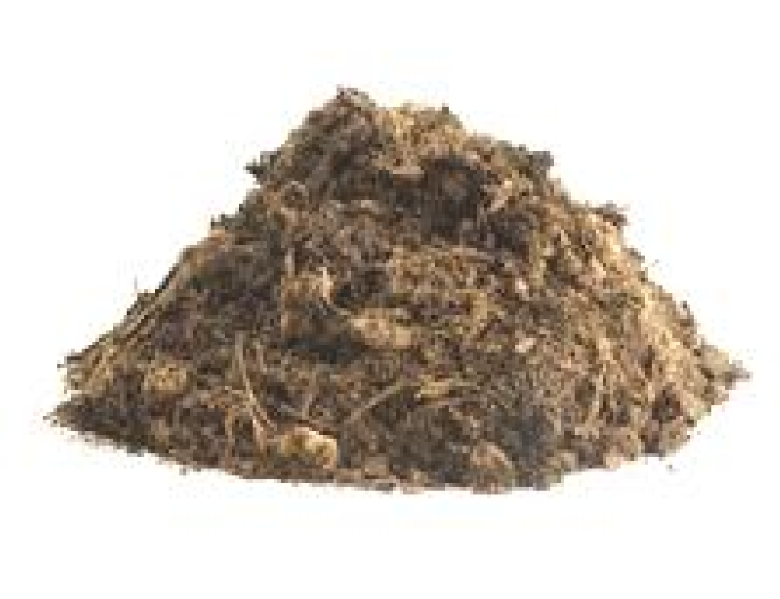
Westfield High School
Annual Bagged Mulch Sale
to benefit the Safe & Sober All-Night Grad Party!

Orders must be placed by March 28, 2018
For Delivery or Pick up on April 6 & 7, 2018
Total Delivery and Spreading Orders limited! Order Early because we always sell out!!
This is the major fundraiser to support a fun, safe and sober graduation party for the Class of 2018, as well as other vital PTSA programs. We rely on your support!
Get high-quality, double shredded hardwood mulch delivered
right to your driveway (WHS boundaries only) at a great price and for a great cause.
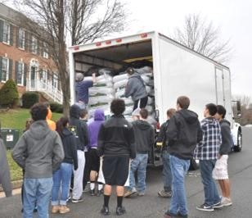
As an added bonus, a WHS Athletic Team will even spread your mulch for you,
at only $2.50 per bag! (15 bag minimum, WHS boundaries only – order early because spreading always sells out!)
For more information email: bulldogmulch@westfieldhs.org
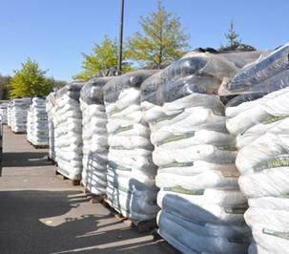
Order today and pay online! http://ptsa.westfieldhs.org
Or Attach Check or Money Order payable to “WHS ANGP,” and mail to:

WHS ANGP Mulch Sale
4700 Stonecroft Blvd. Chantilly, VA 20151
Name:__________________________________________________________________________________
Address (WHS boundaries only):_______________________________________________________________
City: _______________________________________ Is home on a pipestem or long driveway? ________
Subdivision (must be included for delivery):_____________________________________________________
Please provide an email address and telephone number where you can be contacted live, if needed, on April 8 (or rain date April 14). Very Important!

Email Address: ____________________________________ Phone: ( ________ ) ____________________
I would like to help volunteer on Mulch Day! Please contact me! (We need lots of volunteers!)
Check One Below: (Total delivery and spreading orders are limited! Order early before we sell out!!)
Pick up at WHS Parking Lot Free delivery (15 bag minimum; placed on side of driveway; WHS area only)
Description | Quantity | Cost Per Bag | Amount
*High Quality Double Shredded Hardwood Mulch (3 cu.ft.) |  | $5.00
*Bags Donated for WHS Butterfly Garden & Landscaping |  | $5.00
Mulch spread on April 8 (rain date April 15) |  | $2.50
Total
*$2.60 per bag of purchased mulch is a deductible donation on your tax return.

