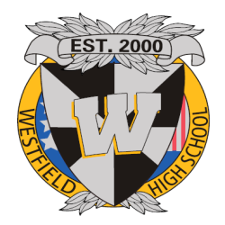
WeSTEP 2018 Westfield Senior Transition Enrichment Program
May 22nd to June 5th 2018

4700 Stonecroft Boulevard Chantilly, VA 20151
Dear WeSTEP Internship Sponsor,
Thank you for your willingness to participate in Westfield High Schools WeSTEP Internship Program May 22nd to June 5th 2018. Your assistance with this important phase of the education of our seniors is greatly appreciated. Your intern met the qualifications including a review of grades, attendance, and discipline records. The intern must complete a minimum of 60 hours of field experience in your organization. At the end of the internship the student will give a brief oral presentation at school in lieu of final exams. We are encouraging students to ask questions and keep notes
The student whom you will supervise directly or indirectly for 60 hours has indicated an interest in your particular field. As a means of allowing your intern to explore this interest further, we are requesting your assistance to allow your intern a period of observation and when at all possible to take part in as many hands on activities in an actual real world setting.
As part of this program, we are asking you to complete a final evaluation form at the end of the internship and return it in an envelope addressed to me. This is a confidential evaluation and will not be shared with the student so please provide honest feedback. We will use the evaluation to provide future guidance to our interns. The evaluation has a space to note if you are willing to mentor students in the future.
As partners in educating this student, in the true sense of the word, again we thank you. Students have been looking forward to this experience all year and in many cases is something they are considering as a career field. I would like to thank you in advance for your time and commitment. We look forward to working with you. Please feel free to contact me with any questions, comments, or concerns.
Sincerely,
Tabatha Bragg Advisor, WeStep Westfield High School (703) 488-6391 tgbragg@fcps.edu

